Testing

AT App

Cristhian Alvarez

Impact mobile  cristhian.alvarez@impactmobilehn.com

Content

Get patients 2

Simple 2

Limit # 3

Limit # Skip # 4

Insert Patient 6

Success 6

Duplicate key 7

Ambiguous data 8

Erroneous data 9

Missing fields 10

Delete Patient 11

Ambiguous id 11

Missing id 11

Success 12

# Get patients

## Simple

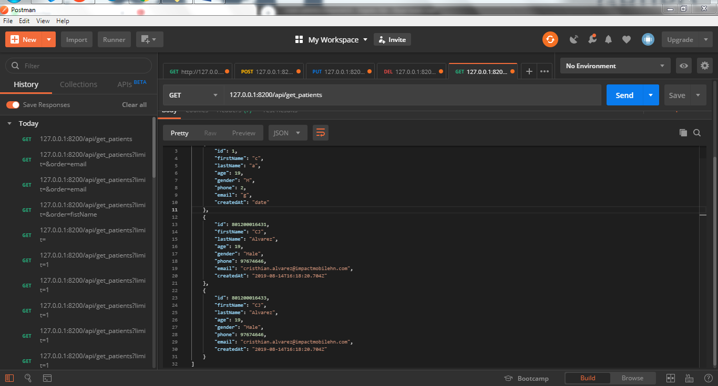

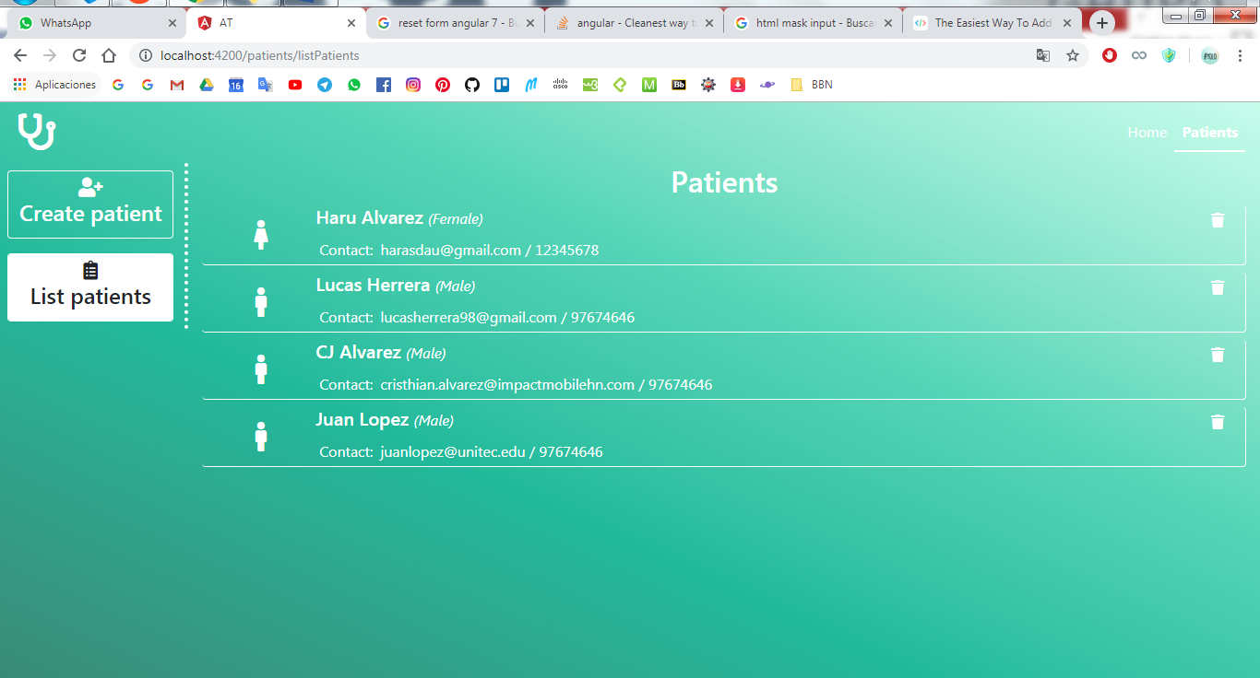

## Limit #

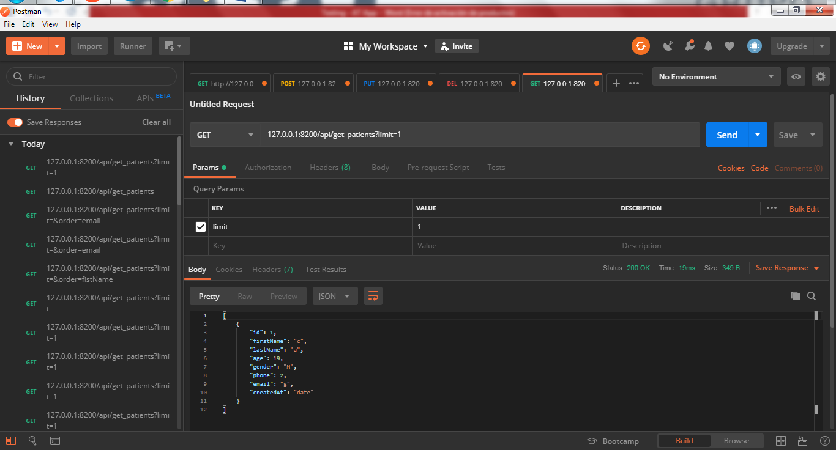

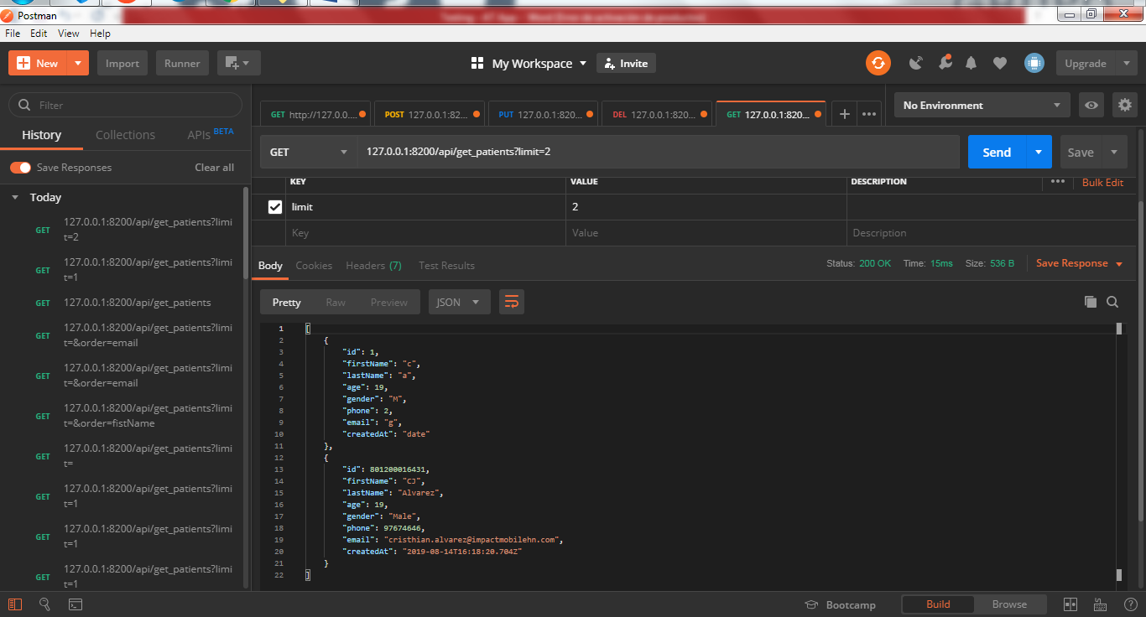

## Limit # Skip #

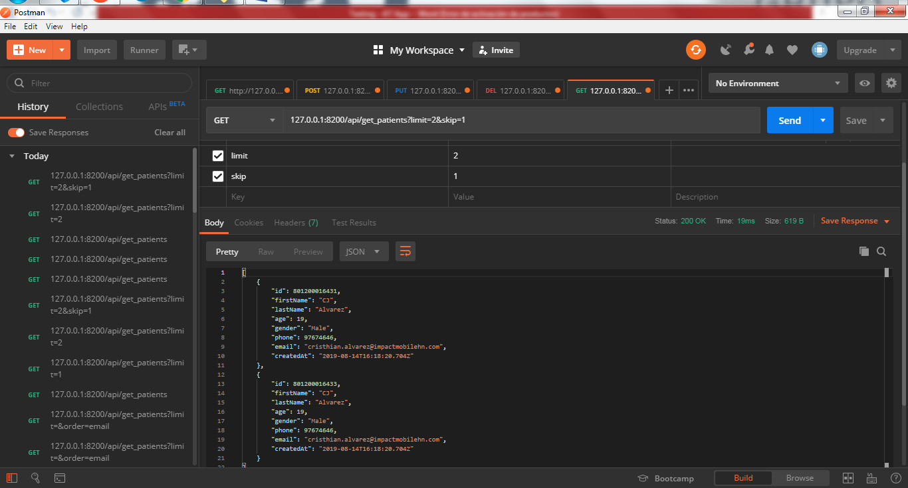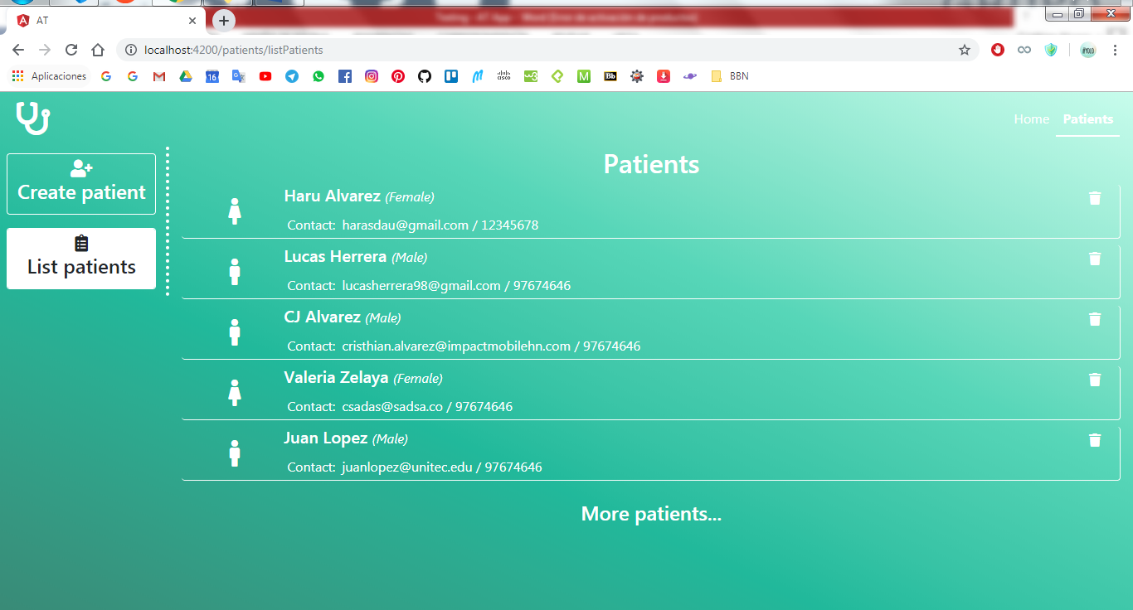

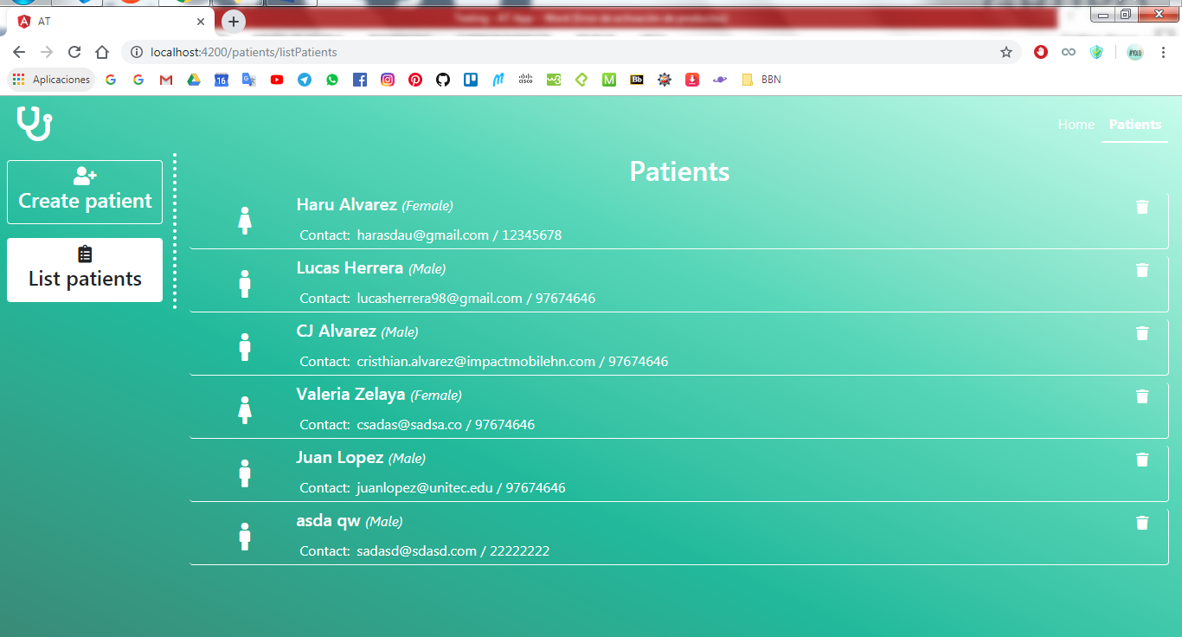

# Insert Patient

## Success

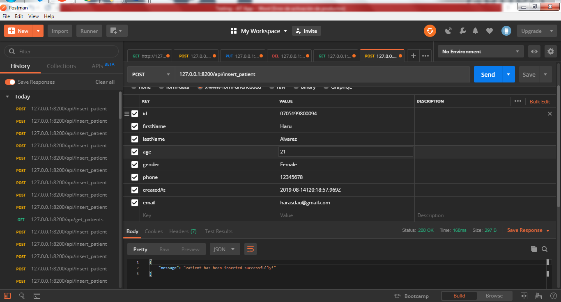

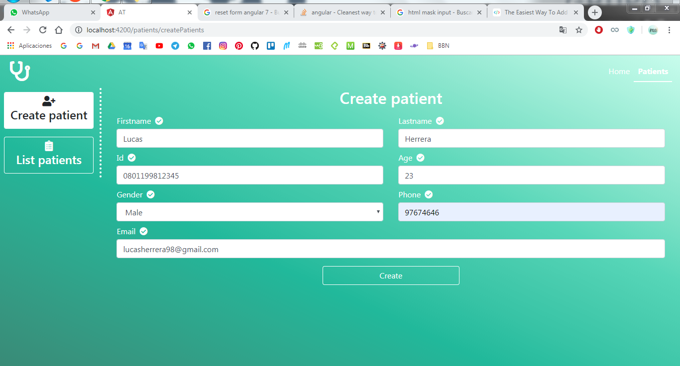

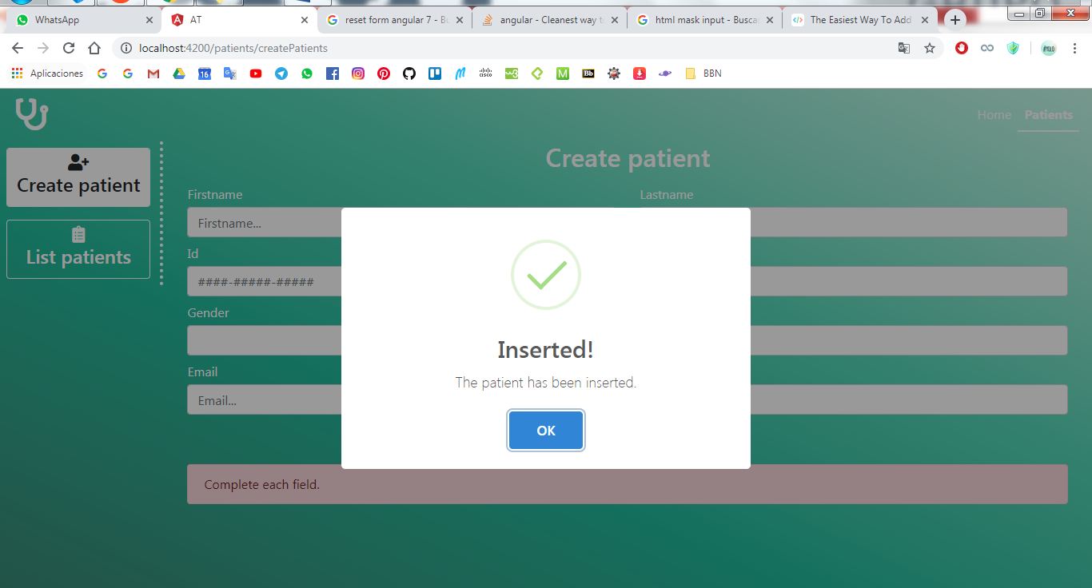

## Duplicate key

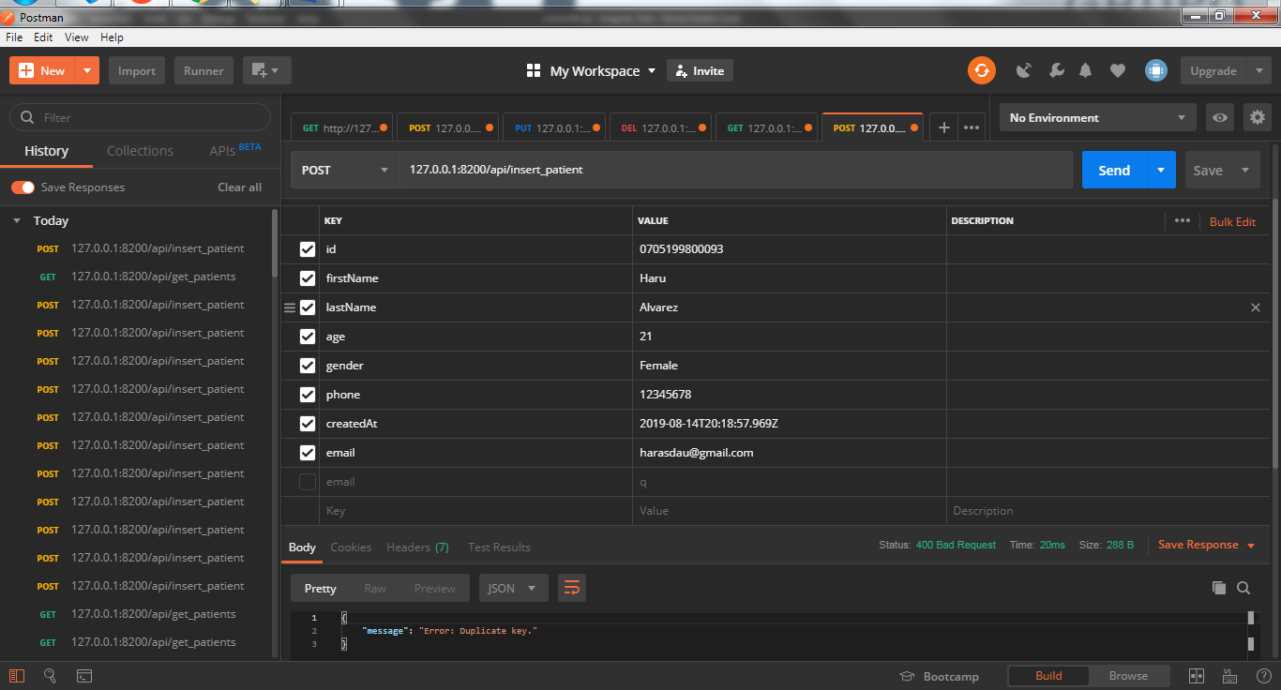

## Ambiguous data

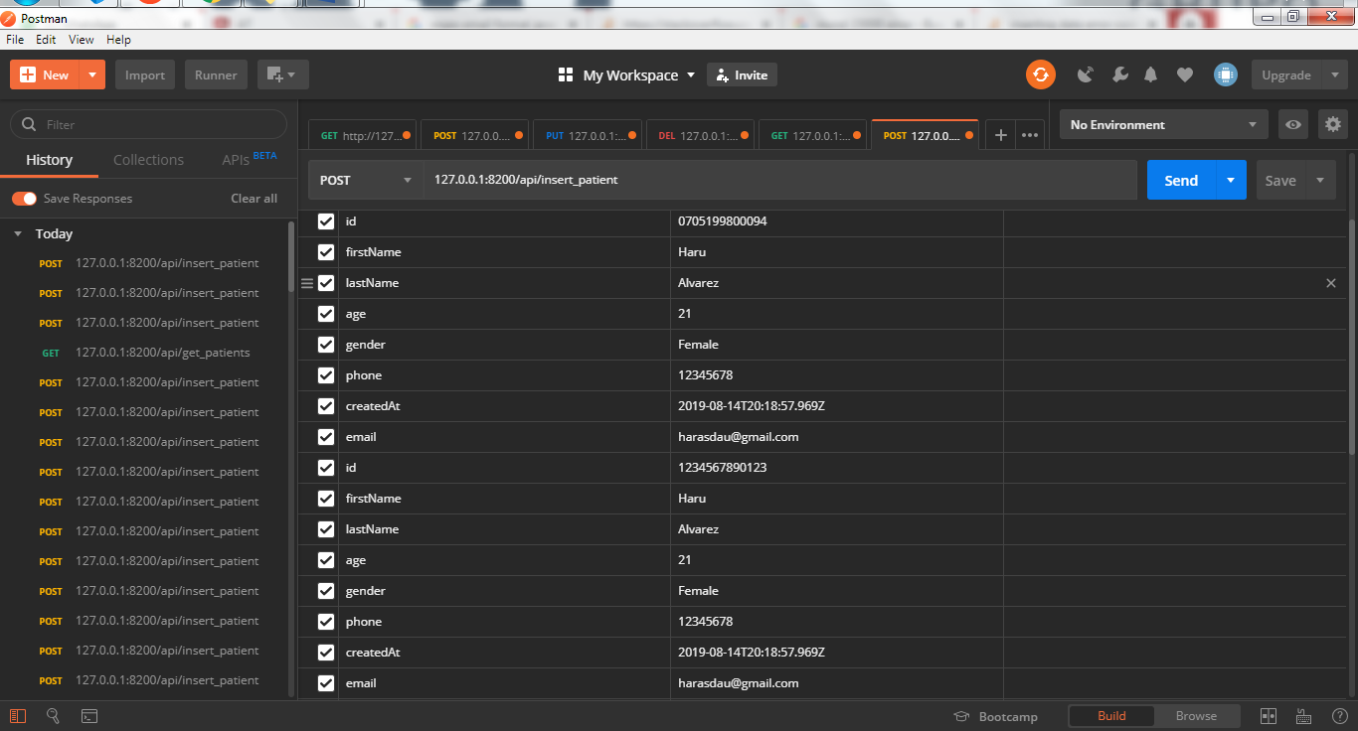

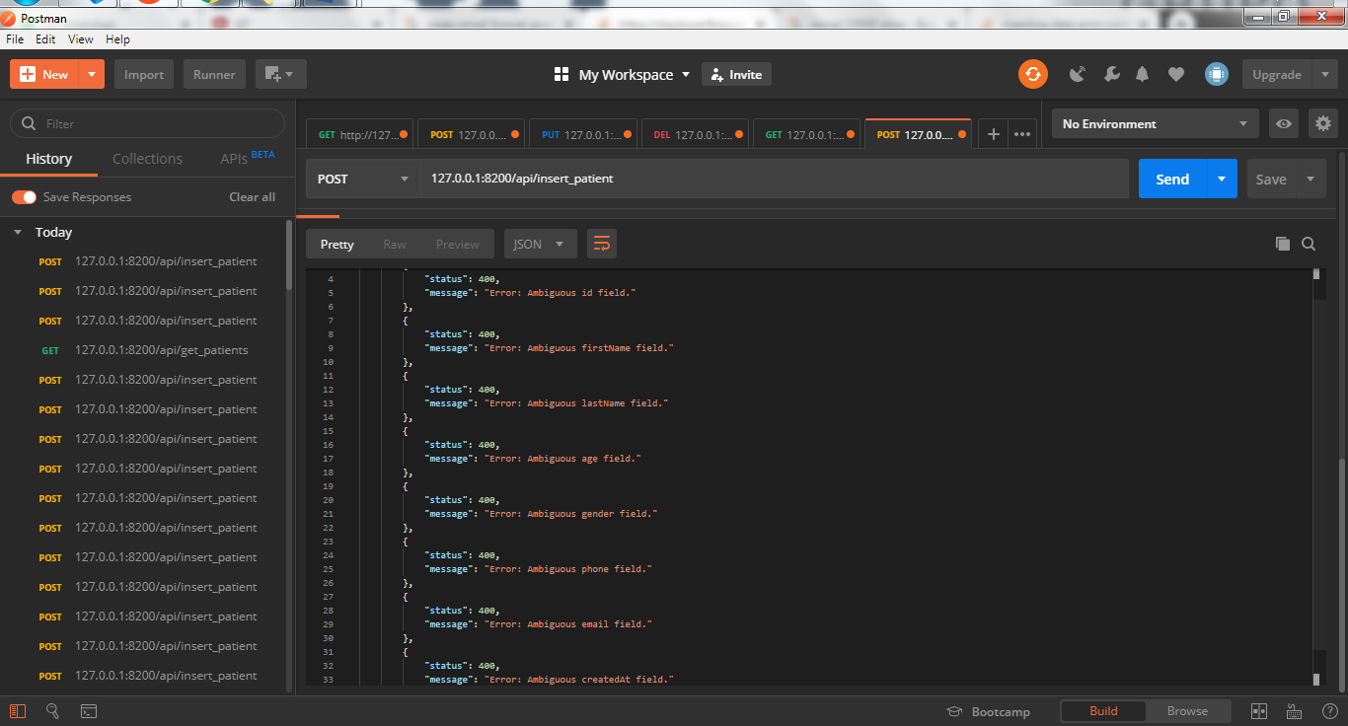

## Erroneous data

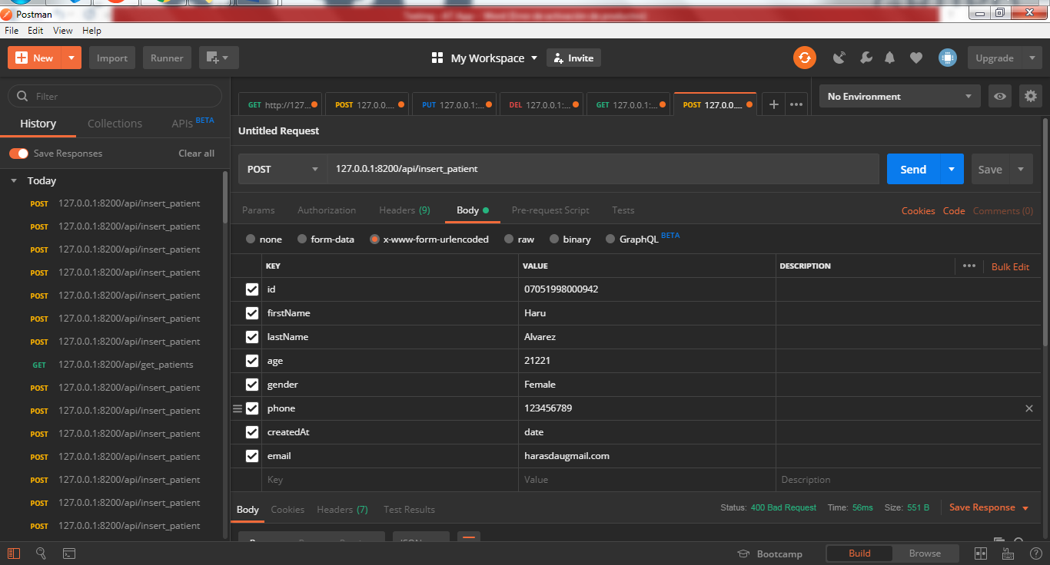

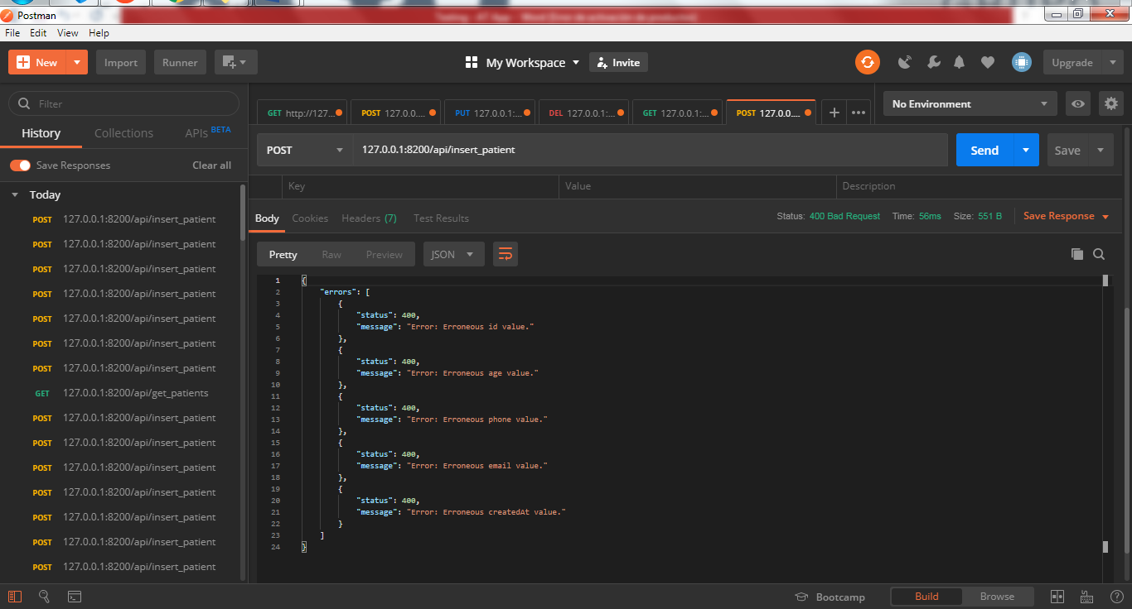

## Missing fields

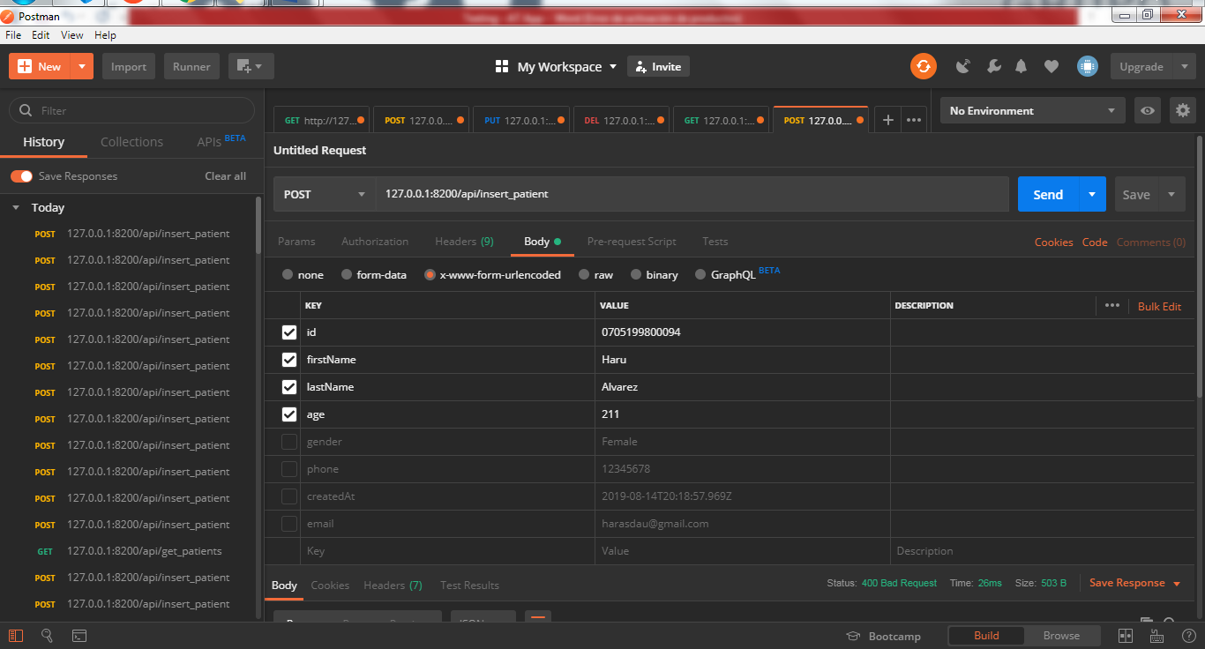

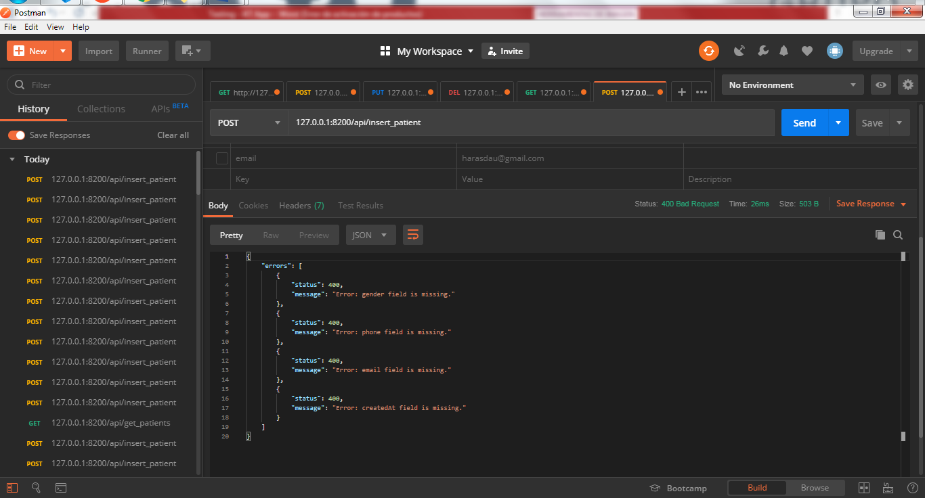

# Delete Patient

## Ambiguous id

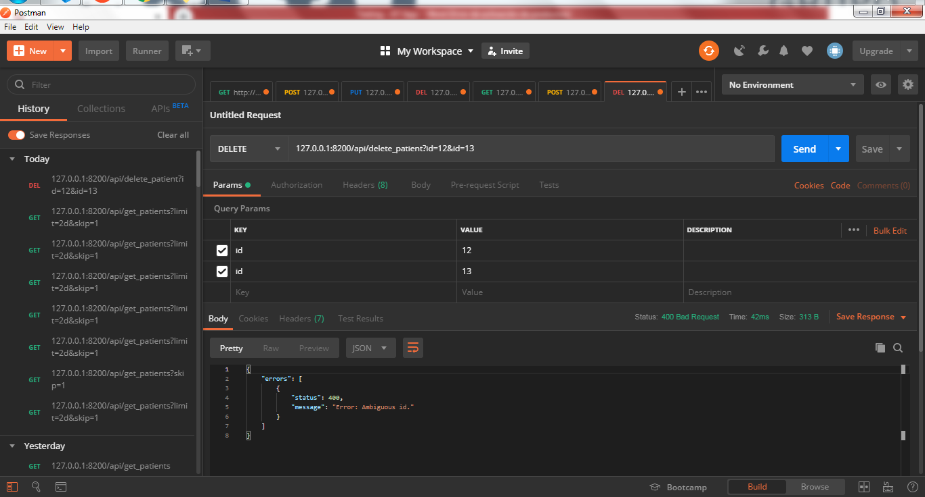

## Missing id

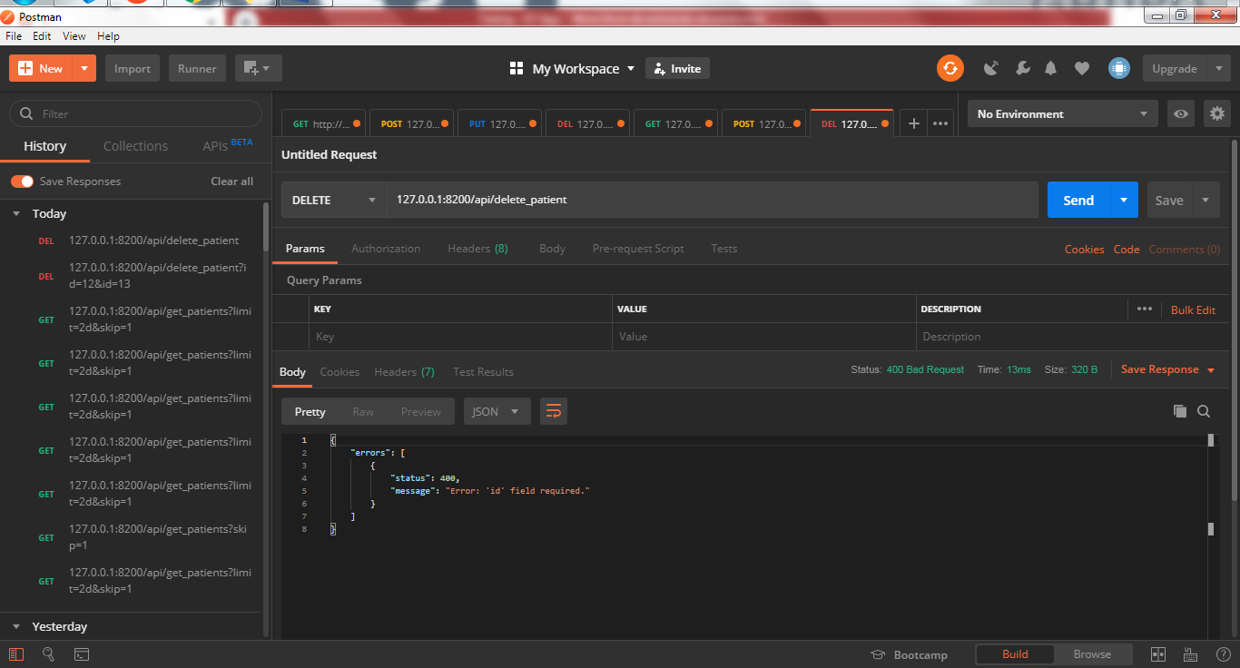

## Success

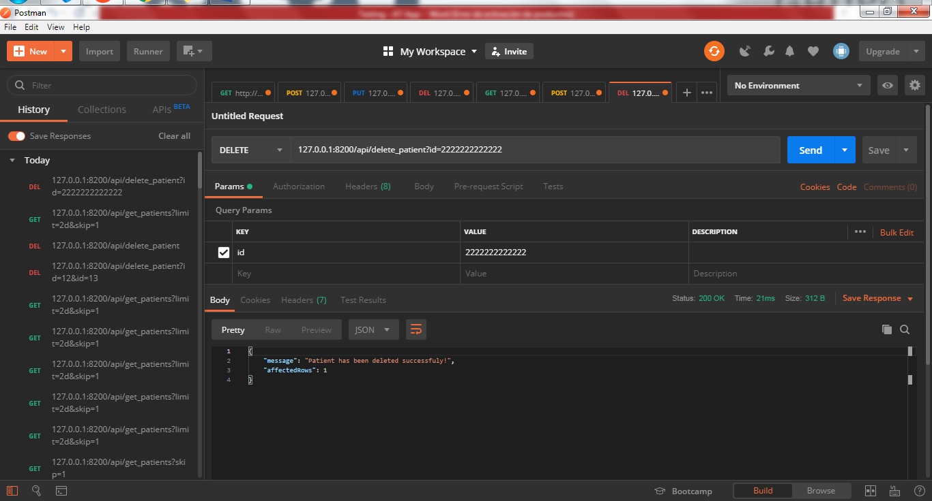

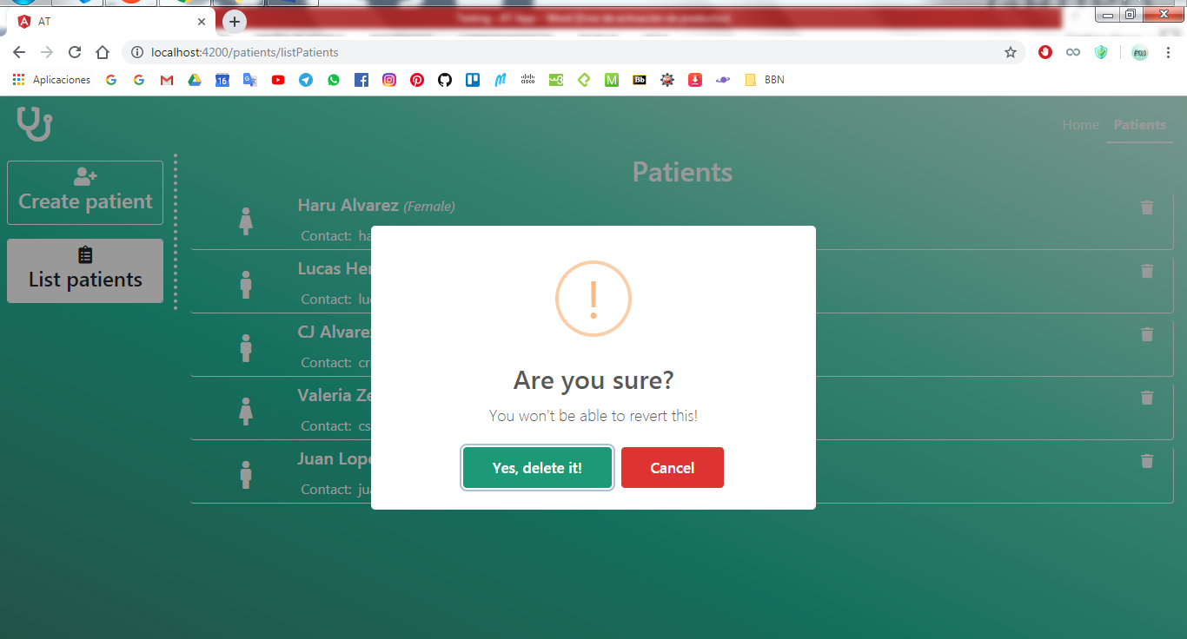

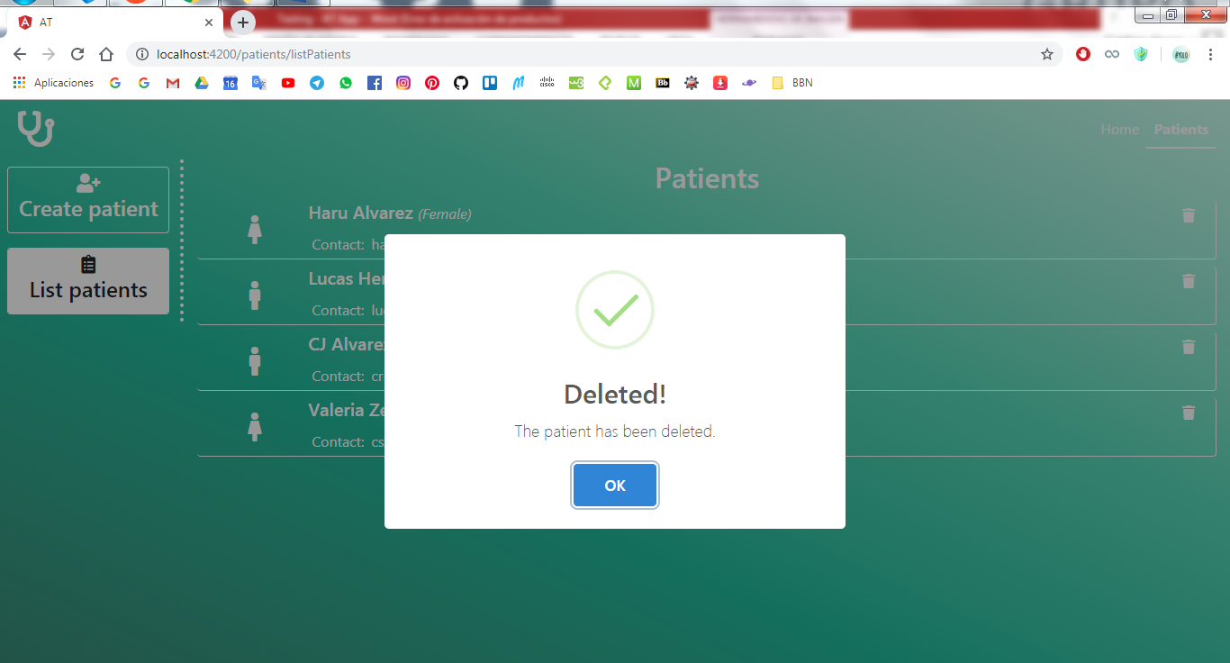

Id doesn’t exist

